# 7. Project Display Screens

###### 7.1 Mobile Application

## 7.1. Splash screen



**Figure 7 1: Splash Screen**

## 7.2. Get Started Screen

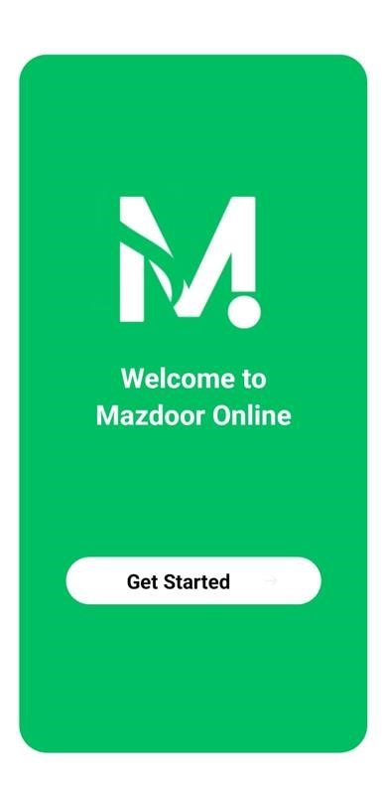

**Figure 7 2: Get Started Screen**

## 7.3 Main Screen

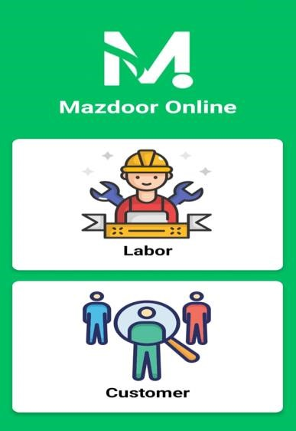

**Figure 7 3: Main Screen**

## 7.4. Labor Login Screen

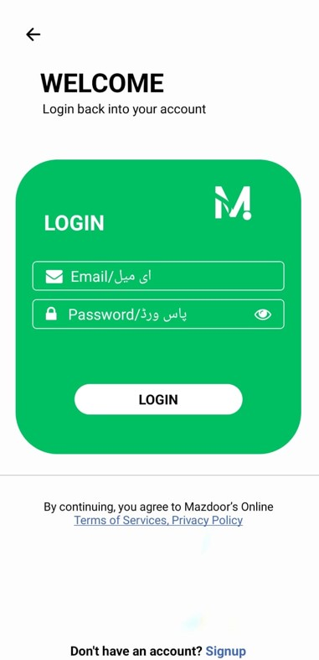

**Figure 7 4: Labor Login Screen**

## 7.5 Labor Signup Screen

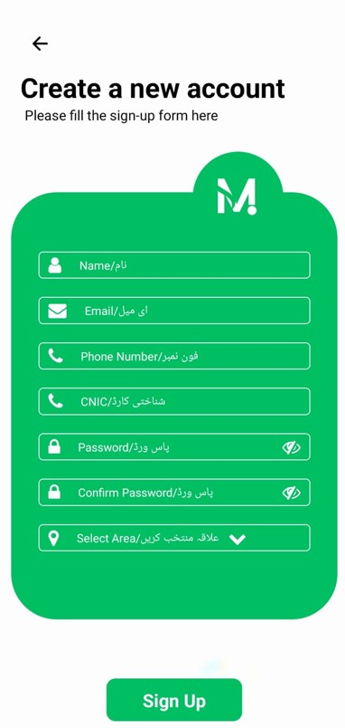

**Figure 7 5: Labor Signup Screen**

## 7.6. Labor Identification

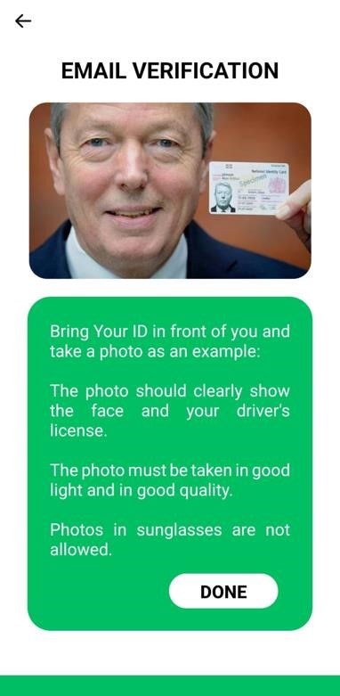

**Figure 7 6: Labor Identification**

## 7.7 Labor Choose Skill Screen

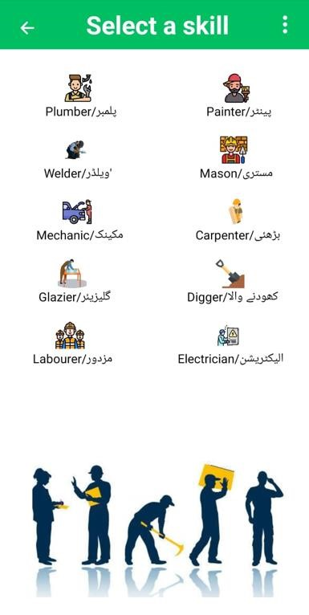

**Figure 7 7: Labor Choose Skill Screen**

## 7.8. Labor Work Proposal Screen

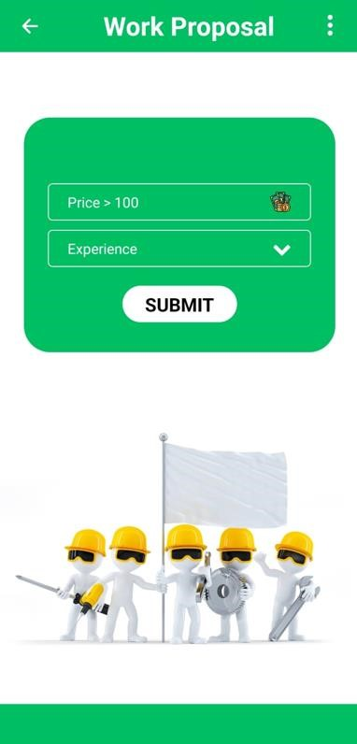

**Figure 7 8: Labor Work Proposal Screen**

## 7.9 Labor Profile Screen

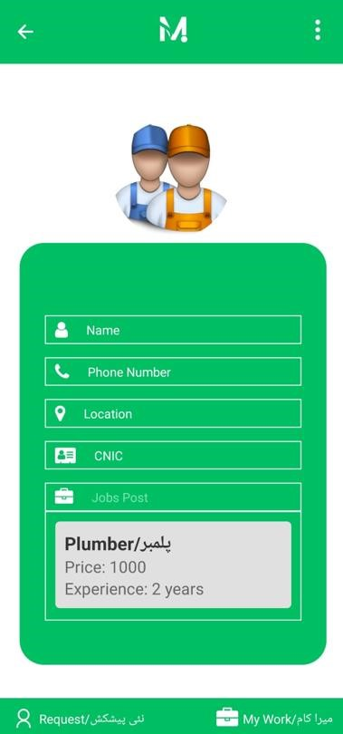

**Figure 7 9: Labor Profile Screen**

## 7.10. Labor Update Profile Screen

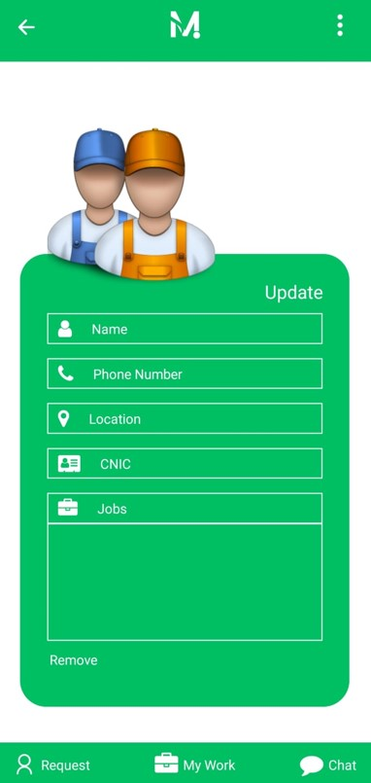

**Figure 7 10: Labor Update Profile Screen**

## 7.11 Pop up Screen

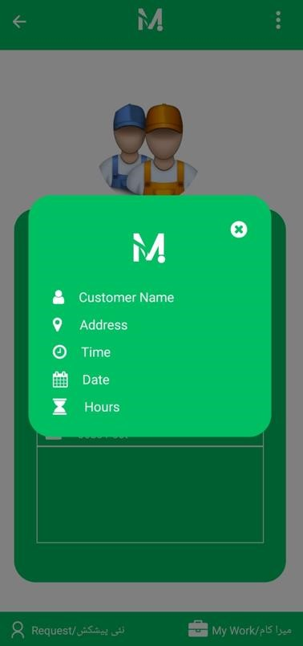

**Figure 7 11: Pop up Screen**

## 7.12. Labor Menu

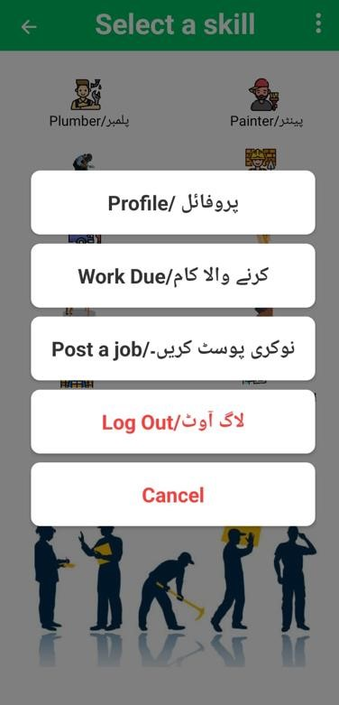

**Figure 7 12: Labor Menu**

## 7.13. Labor Offers

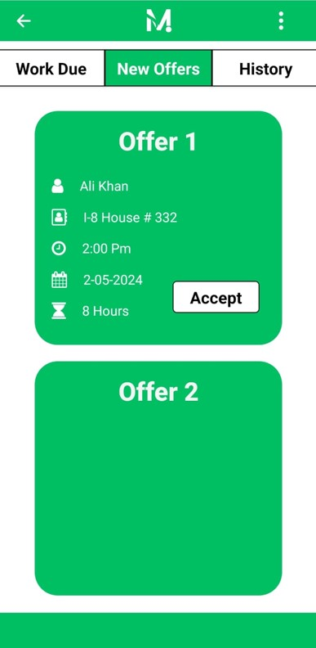

**Figure 7 13: Labor Offers**

## 7.14. Labor Work Due

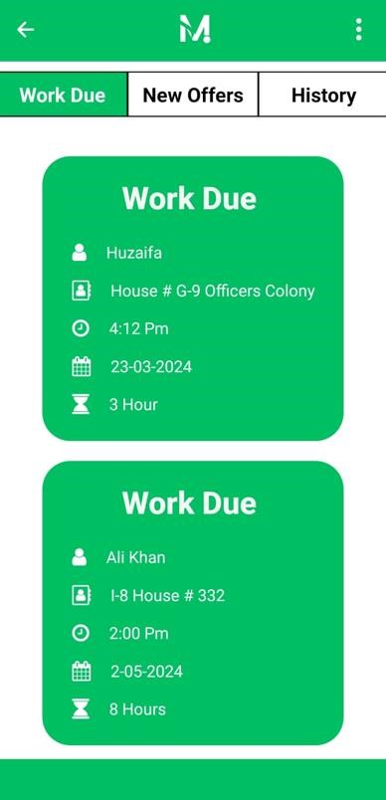

**Figure 7 14: Labor Work Due**

## 7.15 Labor History

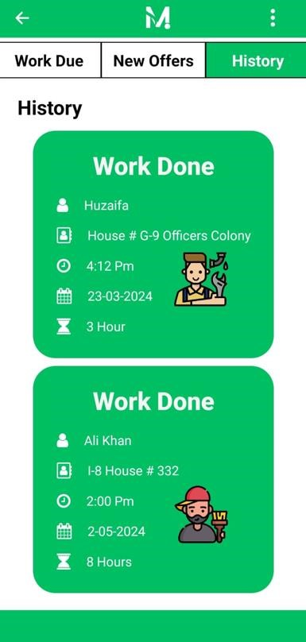

**Figure 7 15: Labor History**

## 7.16. Customer Home Screen

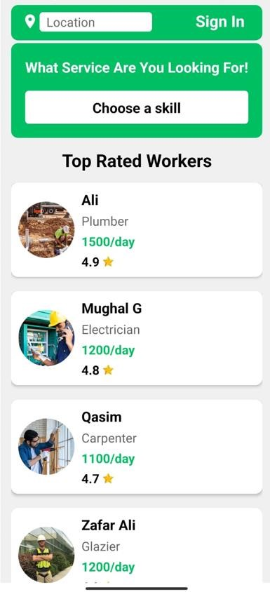

**Figure 7 16: Customer Home Screen**

## 7.17. Customer Login Screen

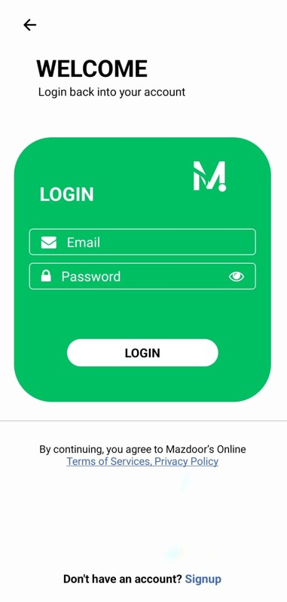

**Figure 7 17: Customer Login Screen**

## 7.18. Customer Signup Screen

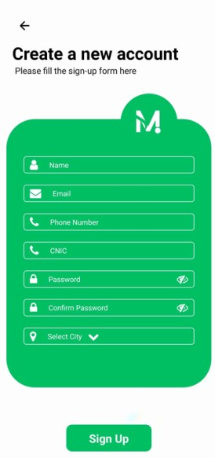

**Figure 7 18: Customer Signup Screen**

## 7.19 Customer Screen after Login

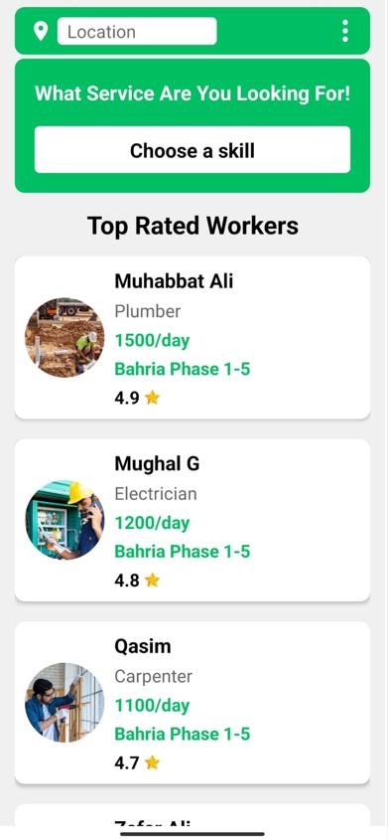

**Figure 7 19: Customer Screen after Login**

## 7.20. Customer Profile Screen

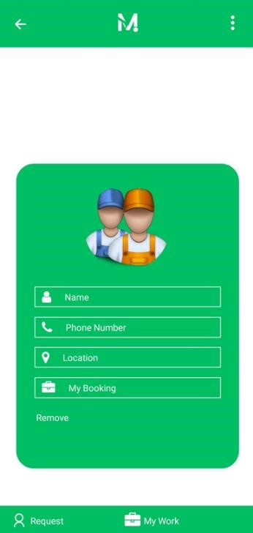

**Figure 7 20: Customer Profile Screen**

## 7.21 Customer Update Profile Screen

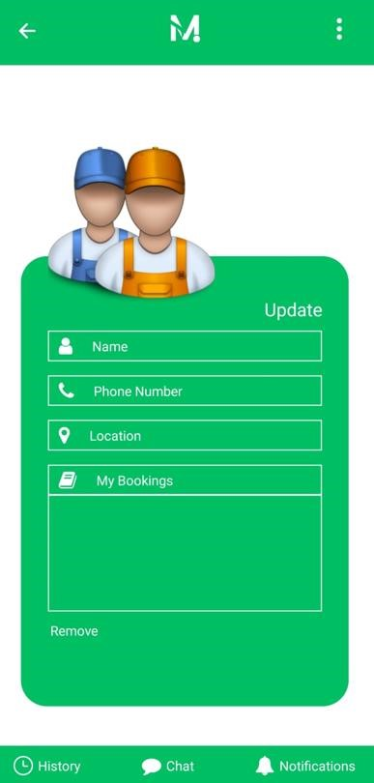

**Figure 7 21: Customer Update Profile Screen**

## 7.22. Customer Dropdown List

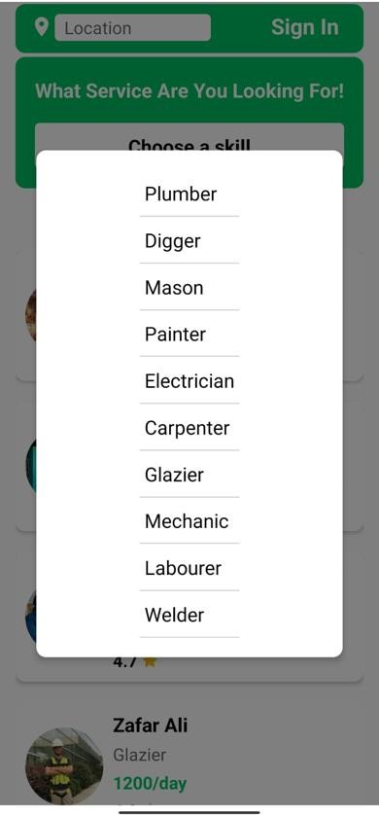

**Figure 7 22: Customer Dropdown List**

## 7.23 Customer Search Location

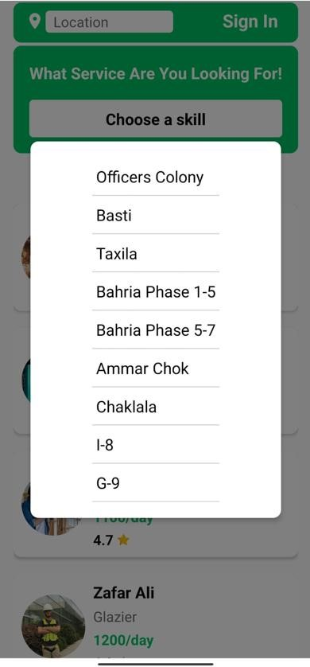

**Figure 7 23: Customer Search Location**

## 7.24. Customer Menu

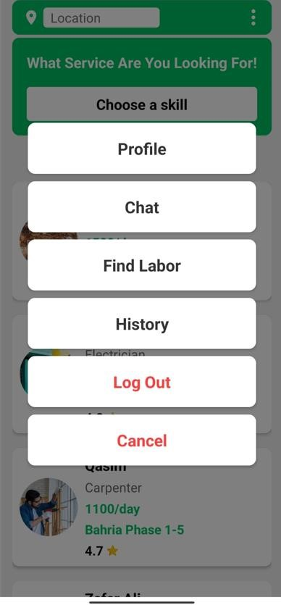

**Figure 7 24: Customer Menu**

## 7.25 Customer Book Labor

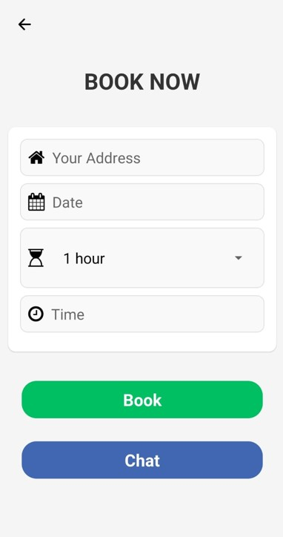

**Figure 7 25: Customer Book Labor**

## 7.26. Customer Chat

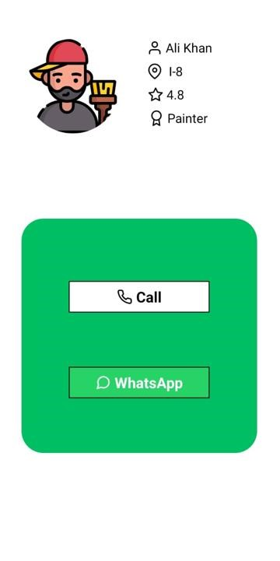

**Figure 7 26: Customer Chat**

## 7.27 Customer Rating to Labor

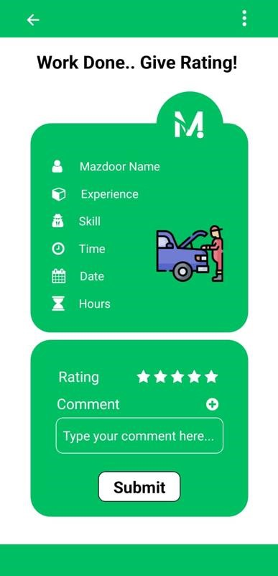

**Figure 7 27: Customer Rating to Labor**